Chapter 8, Problem 3.

Refer to the circuit shown in Fig. 8.64. Calculate:

(a) i_{L}(0⁺), v_{C}(0⁺), and v_{R}(0⁺),

(b) di_{L}(0⁺)/dt, dv_{C}(0⁺)/dt, and dv_{R}(0⁺)/dt,

(c) i_{L}(∞), v_{C}(∞), and v_{R}(∞).

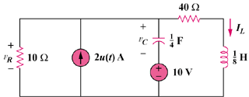

Figure 8.64
For Prob. 8.3.

